- Pattern Recognition Systems Proposal for Group 10
Presentation date：06/10/2026
- Project Name：HomeEase - Your home care buddy
- Problem Definition
- Group number：group10
- Group member：
- Gao Xinghe (A0305470M)
- Lin Kai (A0352380J)
- Sun Yancheng (A0335090L)
- Yu Yuchen (A0356318Y)

- 1. Introduction
For older adults, falls have become the largest single source of unintentional injury, and the burden keeps growing as populations age. According to the World Health Organization, falls cause about 684,000 deaths worldwide each year and are the second leading cause of unintentional injury death, with people over 60 accounting for the largest share; a further 37.3 million falls a year are severe enough to require medical attention.
Singapore is a clear illustration. In 2026, citizens aged 65 and above reached 21.4% of the population, which formally places the country in the "super-aged society" category defined by the United Nations. Data from the National Trauma Registry show that about 63% of fall-related hospital admissions involve people over 65, and that falls account for nearly 90% of all trauma admissions in that age group.
Yet despite this unambiguous safety need, existing home-monitoring products still have structural weaknesses in how they detect risk:
(1) False alarms are frequent. A single sensing channel cannot say where the person is or what posture they are in, so bending down to pick something up, or sitting down and standing up, are repeatedly mistaken for falls. Three false alarms in a day is enough for an older adult to uninstall the app: churn does not come from a missed fall, it comes from being nagged every day.
(2) No single modality can support a trustworthy decision. Acceleration says nothing about posture, vision fails under occlusion, and acoustics can only report that an event occurred. Getting both "no missed real falls" and "no false alarms on ordinary movement" is something no single-modality design can deliver by construction.
(3) Monitoring is passive rather than active. Once the older adult stops wearing the wearable, the whole monitoring chain fails silently, and the family has no idea that it has.
The system we propose addresses both ends of the fall problem. It combines impact-and-stillness pattern recognition on phone accelerometer data, keypoint estimation and temporal action classification from camera video, and a voice-confirmation mechanism driven by speaker verification and semantic judgement. The same pose recognition is reused to count and coach the older adult's daily exercise. The system detects and responds to a fall the moment it happens, and reduces the probability of a fall in advance through continuous exercise coaching.

- 2 Problem Definition
- 2.1 Background for Market Perspective
Singapore has just crossed the threshold the United Nations defines as a "super-aged society", reaching that status in 2026. What matters for the market is not the label but its consequence: the long-standing assumption that an adult child is at home to look after an older parent is failing structurally, and protection for older adults living at home has moved from a niche concern to a mainstream need.
The burden falls impose on Singapore is rigid. About one in three Singaporeans aged 65 or above falls at least once a year, and nearly 70% of those falls happen at home, most often in the bathroom, kitchen or living room of an HDB flat. Falls account for roughly 85% of all injuries in this age group, 63% of patients hospitalised for a fall are over 65, and the consequences of a hip fracture are severe: more than 20% of Singaporeans who sustain one die within a year.
Policy is moving in the same direction. The Ministry of Health's Age Well SG programme is built on an integrated community network spanning prevention, intervention and rehabilitation. The Housing and Development Board (HDB) has already deployed the Smart Elderly Monitoring and Alert System (SEMAS) in rental flats, and the enhanced Home Personal Care service rolled out island-wide from 2026 explicitly includes technology-enabled fall monitoring and response.
- 2.2 Market Research
- 2.2.1 Market Size and Growth
Citizens aged 65 and above reached 21.4% of the population in 2026, up from 20.7% in 2025 and 13.7% ten years earlier. The population aged 80 and above has grown to 152,000, a 60% increase over the same decade, and by 2035 more than one in four Singapore citizens will be over 65. Over this period the working-age share fell from 64.3% in 2016 to 59.3%, and the dependency ratio deteriorated from 5.4 to 3.2. In short, the assumption that an adult child is at home to provide care is failing structurally, and the market for home-based fall protection grows as a result.
- 2.2.2 Key Players and Their Gaps
Fall-detection players:
– Wearable bands and emergency buttons — health bands and pendant-style help buttons.
– Camera-only monitoring — consumer pan-tilt cameras and AI cameras.
– mmWave/LiDAR radar and infrared motion sensors.
– Smart speakers used to call for help.
Exercise-companion players:
– Community group classes — HPB's Steady Lah! and SportSG's CALM programme.
– Self-directed apps and activity tracking — the Age Strong module in Healthy 365, and consumer smartwatches.
– Follow-along exercise videos.
The two groups are locked into quadrants that do not overlap. Fall-detection products sit on a "single modality plus dedicated hardware" track, and their four routes fail in ways that do not overlap either: wearables fail on adherence, vision fails on privacy, and radar and infrared fail on cost and decision accuracy. Exercise-companion products all depend on in-person organisation or report only aggregate totals, so they fail on reach and on movement-level understanding.
- 2.2.3 User Needs and Opportunity
Trustworthy decision — a real fall must be known immediately, and when nothing has happened the system must stay out of the way. The system has to make clear where the person is, what posture they are in, and whether they genuinely cannot get up.
Prevention and practice combined — the moment an older adult uses the product is not the day they fall but every ordinary day. On days when nothing goes wrong, the product should still be lowering the chance that something will.
Controllable false alarms — "prioritise recall in candidate detection, prioritise false-alarm control in emergency alerting". This is the hard constraint on the user experience and the first principle behind every tier of the system's design.
What both groups of players avoid is exactly the position this system takes: no new dedicated hardware, but multimodal cross-validation using the accelerometer in a phone the older adult already carries and a camera already in the home, with a single pose-recognition pipeline linking practice (preventing a fall) and alerting (fall alarms) into one chain.
- 2.3 Background for Product Perspective
These three needs remain unmet because existing approaches have structural weaknesses at four points.
(1) The decision to be monitored is left to the older adult. The problem with bands and pendant buttons is not their design, but that they turn "am I being monitored?" into an action the older adult has to complete in person every day. The moment they stop wearing the device, the monitoring chain fails silently, and the family does not know that it has.
Voice of the user — "Because I live alone, I used to worry that I would fall and no one would come to help me," from a 72-year-old who lives alone, interviewed as a beneficiary of the HoME+ system. Source: The Straits Times, October 2024.
(2) False alarms are the leading cause of churn. The real hidden cost is not a missed fall but a false alarm: repeated false alarms quickly exhaust the older adult's trust in the system. This weakness persists even in the government-backed schemes already deployed in Singapore.
Voice of the user — "The original version triggers whenever anything moves, even a curtain. The accuracy is not enough to really tell whether it is the senior, or a human at all, or just their pet," from a senior service assistant manager at the Singapore Red Cross, speaking about the earlier version of HoME+. Source: The Straits Times, October 2024.
(3) A single signal cannot carry a trustworthy decision. Acceleration carries no posture information, vision fails under occlusion and in low light, and acoustics can only confirm that a sound occurred, not what posture the person is in. This is a multimodal cross-validation problem rather than a matter of tuning a single algorithm.
Voice of the user — HDB's own summary of the SoundEye live-in trial in Queenstown identifies the main challenge as "finding a suitable group of participants, testing the fall detector in real living environments, and being able to validate and collect real-world data". Source: PEP / Singapore Business Federation Awards 2023, HDB × SoundEye case.
(4) Fall risk could be lowered in advance, yet existing products respond only after the fact. Resistance training is a first-line intervention in the Singapore Clinical Practice Guidelines for Sarcopenia, so a substantial share of falls is preventable. But the government-backed classes require older adults to travel and arrive on time, and five years of cumulative delivery has reached just over 25,000 attendances — still a small fraction of a population of more than 630,000 older adults. Self-directed apps and follow-along videos, meanwhile, record only step counts or play movements back without counting repetitions or correcting form.
Voice of the user — "Steady Lah! showed promising early results, but the design of the programme and its reliance on delivery by healthcare professionals make it challenging to scale to more sites to meet overall community demand," from a programme summary of Singapore's community frailty intervention. Source: Frontiers in Public Health, 2024.
- 2.4 Problems to Solve
Three things follow for the system.
First — no missed real falls and no false alarms on ordinary movement. One line of evidence comes from impact-then-stillness in the accelerometer signal; the other comes from a sharp drop in body height and a lying posture in the camera's skeleton output. The two are cross-checked: agreement on both channels produces an emergency, while a single-channel anomaly, or one channel being unavailable, produces a "pending verification" event.
Second — clear a false alarm in a single sentence. For someone who has fallen, the only interaction still available is speech. The system uses a voice prompt with speaker verification to obtain a human confirmation; the reply counts as supporting safety evidence rather than automatically cancelling an emergency, which replaces the "you must tap your phone" workflow.
Third — turn everyday movement into countable exercise data so that prevention and practice share one sensing pipeline. The same pose recognition translates daily movement into repetition counts, duration, completion and balance scores, and a daily plan with spoken feedback drives sustained exercise, so that the product keeps lowering the chance of a fall even on days when nothing happens.
- 2.5 Goal
To build a multimodal home fall-protection system that both responds to falls and prevents them.
For the older adult, this means:
– a fall is detected immediately, through the wearable accelerometer and the camera together;
– saying "I'm fine" out loud clears a false alarm, with no app to learn;
– daily exercise is guided by spoken prompts and logged automatically, which helps prevent falls.
For the family, this means prompt notification after a fall and a summary of the older adult's exercise activity.

- Core Algorithm Design
In this section, we introduce the three main algorithms required by the system, with a particular focus on their functions, the pattern recognition techniques employed, and the design of comparative and ablation experiments.
- 3.1 Function 1 Algorithm: Fall Detection
- 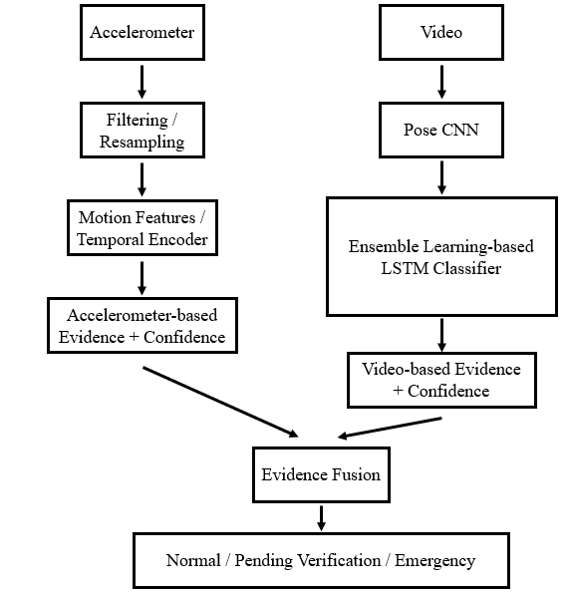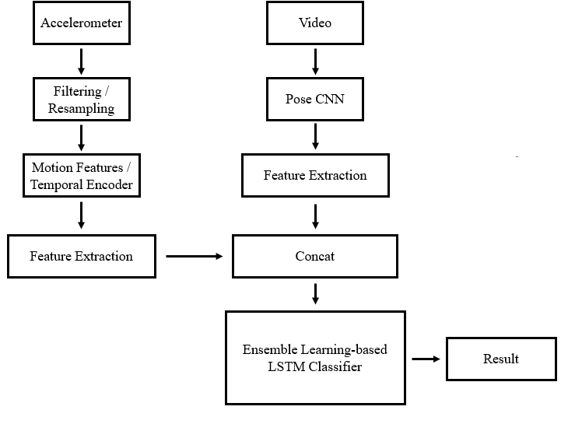
- (a) （b）
- Figure 3-1. Fall Detection Algorithm Workflow
This algorithm integrates accelerometer data with video-based visual information for fall detection. To investigate the impact of different multimodal fusion strategies on recognition performance, two fusion architectures are designed and compared: decision-level fusion (Late Fusion) and feature-level fusion (Feature-level Fusion).
The experimental evaluation mainly compares the following modules:
- Accelerometer signal filtering and preprocessing methods;
- Accelerometer feature selection and feature extraction methods;
- Pose CNN network architectures;
- Visual kinematic feature extraction methods;
- Multimodal feature/evidence fusion methods;
- Temporal classification models and ensemble strategies.
The main techniques involved include Intelligent Sensing, Supervised Learning, Machine Learning, Deep Learning, and Ensemble Learning.

Approach 1: Decision-Level Fusion (Late Fusion)
Approach 1 adopts a decision-level multimodal evidence fusion architecture.
The tri-axial accelerometer signals are first processed through filtering, resampling, and temporal window segmentation. Features such as impact peak magnitude, motion intensity, and post-impact inactivity are then extracted. A temporal classification model is subsequently applied to generate accelerometer-based fall evidence together with its corresponding confidence score.
For the video branch, a Pose CNN is first used to extract human skeletal keypoints. Kinematic features, including center-of-mass height, joint angles, torso orientation, and motion velocity, are then calculated from consecutive skeletal sequences. A temporal classification model is subsequently used to recognize the human activity state and generate visual fall evidence together with its confidence score.
Finally, the Evidence Fusion module performs weighted fusion of the two sources of evidence by jointly considering their classification results, confidence scores, signal quality, and temporal consistency. The system outputs one of three event states:Normal / Pending Verification / Emergency
The main advantage of this architecture is that the two modalities remain relatively independent. When one sensing modality is affected by occlusion, missing data, or degraded signal quality, the system can still use the other modality to generate a pending-verification event, thereby improving the fault tolerance and interpretability of the overall system.

Approach 2: Feature-Level Fusion
Approach 2 adopts a feature-level multimodal fusion architecture.
The accelerometer branch performs signal preprocessing and motion feature extraction. In parallel, the video branch uses a Pose CNN to obtain human skeletal sequences, from which temporal kinematic features are further extracted. After temporal synchronization and normalization, the features from the two modalities are concatenated along the feature dimension to form a unified multimodal feature sequence.
The fused feature sequence is then fed into a temporal classification model, allowing the model to directly learn cross-modal temporal relationships between accelerometer variations and changes in human posture. The model ultimately outputs the fall classification result.
The two architectures are evaluated using the same data partitioning strategy and evaluation metrics. Their performance is compared in terms of recognition performance, robustness, and behavior under missing-modality conditions, with the aim of analyzing the differences between decision-level fusion and feature-level fusion.

3.2 Function 2 Algorithm: Exercise Statistics
- 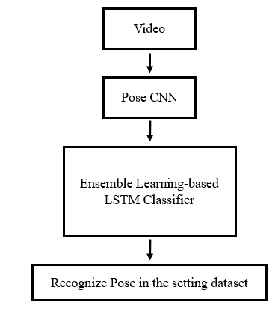
- Figure 3-2. Exercise Statistics Algorithm Workflow
This algorithm reuses the visual pose estimation module from the fall detection algorithm and utilizes sequences of human skeletal keypoints to recognize and quantify exercise movements.
The experimental evaluation mainly compares the following modules:
- Pose CNN network architectures;
- Skeletal kinematic feature extraction methods;
- Temporal action classification models;
- Single-model and ensemble classification strategies.
The main techniques involved include Intelligent Sensing, Supervised Learning, Deep Learning, Machine Learning, and Ensemble Learning.
The system first receives video input from a camera and uses a Pose CNN to extract human skeletal keypoints. Kinematic temporal features, such as joint angles, joint displacements, and changes in the body's center of mass, are then calculated from consecutive keypoint sequences. A supervised temporal classification model is subsequently employed to recognize different phases of an exercise movement.
Taking the Chair Sit-to-Stand exercise in the MVP as an example, the movement is divided into several phases, including sitting, rising, standing, and sitting down. A repetition is counted as valid only when a complete movement cycle is successfully recognized. After action recognition, the system records the number of valid repetitions, exercise duration, and movement completion status, and generates a record for each exercise session.
In future extensions, additional indicators, such as movement completion quality and joint stability, may be further investigated. However, these indicators will only be incorporated as formal system outputs after their definitions and validation methods have been clearly established.

3.3 Function 3 Algorithm: Voice Interaction and Audio Monitoring
- 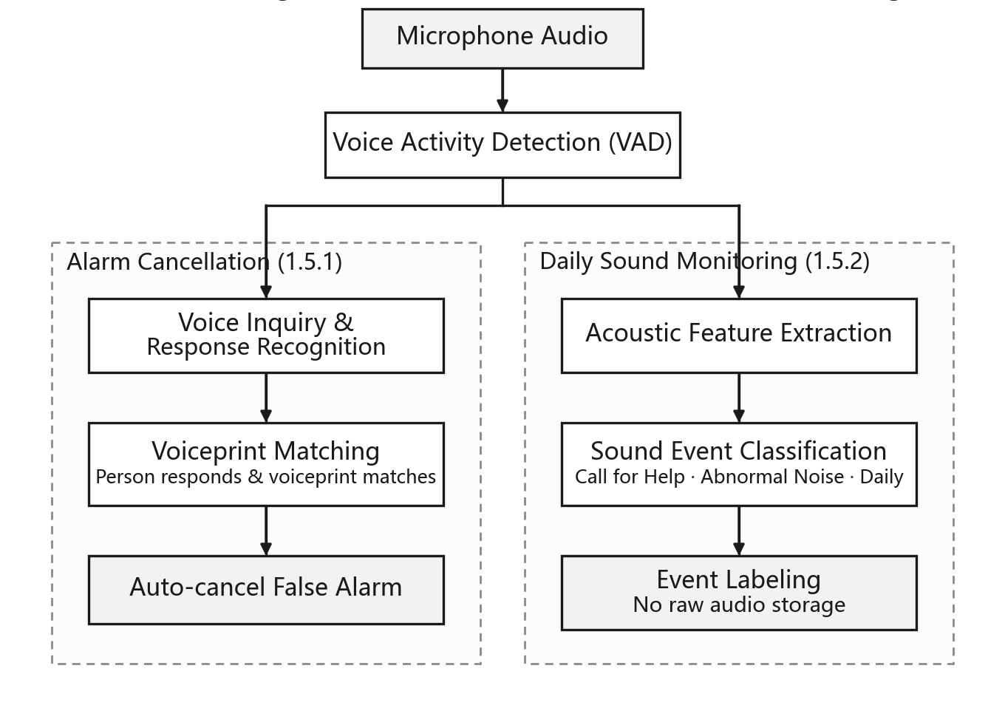

Figure 3-3. Voice Interaction Algorithm Workflow
This module is designed to provide auxiliary voice interaction after a fall event is detected and to explore sound event recognition in home environments.
The algorithm mainly compares the following components:
- Voice Activity Detection (VAD) methods;
- Speech/audio feature extraction methods;
- Sound event classification algorithms.
The audio input is first processed using Voice Activity Detection (VAD) to identify valid audio segments. Depending on the application scenario, these segments are then processed through two branches: voice interaction and environmental sound analysis.

(1) Voice Interaction Branch
When the system detects a suspected fall event, it initiates a voice interaction to ask the older adult about their current condition and recognizes the user's response. The recognized response is then incorporated into the event-handling process as additional supporting evidence.
At the MVP stage, a voice response does not directly cancel an emergency event. In future extensions, Speaker Verification may be incorporated to verify the identity of the respondent using voiceprint features. An automatic confirmation mechanism may then be investigated after false alarm cancellation has been thoroughly evaluated under conditions involving television speech, visitor speech, environmental noise, and other potential interference.

(2) Environmental Sound Monitoring Branch
For valid audio segments captured in the home environment, the system extracts acoustic features and applies a supervised classification model to recognize different sound events, such as:
Help / Impact / Abnormal Sound / Daily Sound
The system stores only the detected event category, timestamp, and necessary statistical information. In principle, raw audio recordings are not retained for extended periods, thereby reducing potential privacy risks.

- 4. Data Collection and Preparation
- 4.1 Data Requirements
The system draws on three kinds of input: acceleration from a wrist-worn band, video from a fixed home camera (converted into body skeletons), and household audio. Fall detection needs wrist accelerometer and video recordings of falls and daily activities; exercise coaching needs skeleton sequences of the target exercises; and the voice and sound functions need spoken replies and labelled household sounds. Ideally these data would reflect the setting the product is designed for: an older adult at home wearing the band, with a TV or appliances running in the background. Public datasets match this setting only in part. Most fall recordings are staged by young volunteers, public exercise recordings rarely include the gentle movements suited to older adults, such as marching in place or heel raises, and household sound collections consist largely of clean, isolated clips. We therefore plan to use public datasets where they are adequate and to fill the remaining gaps with targeted synthetic data and a small set of our own recordings.
The order of the data work follows the MVP scope in Section 7. Fall detection and chair sit-to-stand counting come first. Data for later-stage features, namely additional exercises, speaker verification and household sound statistics, will be prepared when those features are taken up.
- 4.2 Candidate Data Sources
In a preliminary review of 40 publicly available datasets, we compared sensor type and placement, the presence of indoor home scenes, label granularity, the inclusion of older participants and licence terms, and also weighed data volume against the project timeline. Table 4-1 lists the current shortlist. This selection is provisional. If a primary dataset proves unavailable, unsuitable or too costly to process, we will switch to one of the alternatives listed for the same purpose. For large corpora we intend to download only what is needed, such as selected FSD50K clips, a subset of AISHELL-1 speakers and a subset of UP-Fall video trials, which should keep the primary set within roughly 10 to 20 GB.
Table 4-1 Provisional data sources
Purpose | Primary candidates | Alternatives
Fall detection (wrist accelerometer) | WEDA-FALL (wrist smartwatch; includes daily activities of 11 adults aged 77–95); UMAFall and UP-Fall (wrist sensor channels) | FallAllD, SisFall
Fall detection (video) | UR Fall; GMDCSA-24 (home settings), with OmniFall annotations; UP-Fall (camera views recorded together with the wrist sensor) | Le2i, CAUCAFall
Pose estimation and exercise | COCO 2017 keypoints; UI-PRMD (rehabilitation movements including sit-to-stand, with correct and incorrect executions); MM-Fit (pose, wrist smartwatch IMU and repetition counts) | KIMORE, Penn Action, InfiniteRep
Household sounds | FSD50K (selected clips of screams, shouts, thuds, slams and breaking glass); ESC-50; VIVAE (fear and pain vocalisations) | Nonspeech7k, VocalSound, AudioSet
Background audio and speakers | DEMAND (domestic noise); AISHELL-1 (subset of speakers) | MUSAN, CN-Celeb, SeniorTalk (subject to approval)
No single public dataset of wrist-worn sensors is large or varied enough on its own, so for the wrist channel we plan to combine several of them. WEDA-FALL is particularly useful because its older participants recorded daily activities with a wrist device, which gives a realistic basis for estimating false alarms.
Fusion of the two channels can only be evaluated on recordings in which both were captured at the same time. Among the shortlisted public datasets, UP-Fall pairs a wrist sensor with video, and UR Fall pairs video with an accelerometer worn near the pelvis. We will evaluate fusion on these recordings and on the scripted test recordings described in Section 10, and will not combine recordings of different people into artificial synchronised samples. Unpaired datasets are used to train and test each channel on its own.
- 4.3 Data Preparation
The sources differ in sampling rate, units, sensor placement, skeleton format and label definitions, so the first step is to bring them into a common form. The pipeline converts acceleration to common units and a common sampling rate, resamples video to a fixed frame rate and maps all skeletons to a single joint layout. Labels are merged into a small shared set for each function. For falls we expect to follow the OmniFall taxonomy, which separates the act of falling from the state of lying on the floor and fits the impact-then-stillness logic described in Section 3. Household sounds are grouped into the three classes used in Section 3: calls for help, abnormal noises and everyday sounds.
Continuous recordings are then cut into fixed-length windows, with fall windows anchored on the impact so that they cover both the impact and the period that follows. Wrist signals contain far more arm movement than signals recorded at the waist, so daily activities with strong arm motion, such as clapping or hitting a table, will be treated as hard negatives. Window length, overlap and similar parameters will be settled during development based on experimental results.
Where public data are missing, we plan to build three kinds of synthetic data. The first is accelerometer signals of a band that has been taken off, such as a band lying on a table, being picked up or falling off a table, generated from simple physical models and used both as hard negatives and to support detection of whether the band is being worn. The second is skeleton sequences for later-stage exercises that lack public recordings, generated from joint-angle keyframes with varied tempo and body proportions. The third is household soundscapes in which calls for help and abnormal noises are mixed into everyday background sound with simulated room reverberation, together with a small set of Mandarin replies and help calls (for example, “我没事”, “I’m fine”, or “救命”, “help”) rendered with text-to-speech. Synthetic data are intended mainly for training and stress testing, and we plan to keep their share small so that results are not driven by artefacts of the simulation.
Our own recordings follow the test script in Section 10. Team members perform simulated falls on protective mats and a set of daily activities while wearing the stand-in phone on the wrist, filmed by the home camera, with both streams on a shared clock. These sessions are used mainly for fusion tests and for checking the demonstration setup.
To avoid leakage, data are split by participant or source recording before windowing. Earlier work on wrist-based fall detection has reported a clear drop in accuracy when a model is tested on a dataset other than the one it was trained on, so cross-dataset tests will be part of the evaluation where the data allow. Automatic checks (for instance, that a static accelerometer reads close to 1 g) and manual spot checks run throughout, and each processed dataset comes with a manifest and a short data card so that the pipeline can be rerun.
- 4.4 Risks and Contingencies
Parts of this plan depend on conditions outside our control, and some adjustments during the project are likely. Table 4-2 summarises the main data-related risks and how we intend to respond.
Table 4-2 Data-related risks and contingency plans
Risk | Contingency
A dataset becomes unavailable, or its licence is unclear or does not allow our use | Confirm the terms with the authors where possible; otherwise switch to a listed alternative for the same purpose and record the change in the final report
Datasets that need registration or approval (e.g. FallAllD, SeniorTalk) cannot be obtained in time | Rely on openly available data; use such datasets only for additional testing once access is granted
The phone used in the demonstration behaves differently from a wristband (weight, fit, sensor characteristics) | Fasten the phone firmly to the wrist, feed the models raw tri-axial acceleration at the common sampling rate, and check behaviour on our scripted recordings, adjusting decision thresholds if needed
Too few recordings capture wrist acceleration and video together | Report fusion results only on synchronised data and state the sample size; train each channel on unpaired data
Processing takes longer than planned | Complete the MVP data first, download only the required subsets, and keep large corpora in reserve
Public data differ from real home conditions (younger actors, controlled settings, different devices) | Add hard negatives, run cross-dataset tests, and report the remaining gap as a limitation
Sound data are insufficient for reliable training | Rely more on general-purpose audio and speech recognition components (transcription is designed as a replaceable front end from the start) and use our own data for threshold calibration and evaluation
The pose network is not ready when skeleton data are needed | Develop the downstream pipeline with an off-the-shelf pose estimator and regenerate the skeletons once our model is available

5. Technical Stack
Frontend: HTML
Backend: FastAPI (Python)
- Database: SQLite

- 6. Use Cases and Product Workflow
6.1 Intended Users and Operating Scope
The proposed system supports older adults who spend part of the day alone at home and family caregivers who cannot provide continuous in-person supervision. It combines accelerometer readings from the older adult's smartphone with posture information derived from a fixed indoor camera. The system is intended to identify potential falls, initiate an appropriate response, and provide simple exercise tracking through the same visual sensing capability. The older adult uses a minimal interface for status, assistance, and exercise; the family caregiver configures contacts, receives notifications, and records the outcome of each event.
Monitoring is limited to configured indoor areas within the camera's field of view. Detection performance may be reduced when the person is occluded, lighting is inadequate, the smartphone is not carried, or a device is offline. The interface therefore distinguishes a normal monitoring state from reduced coverage and unavailable monitoring. Exercise summaries provide activity feedback; they do not constitute a medical diagnosis or a validated assessment of fall risk.
6.2 Setup and Routine Monitoring
During setup, a family caregiver registers the older adult and emergency contacts, connects the smartphone and camera, identifies the monitored room, and verifies time synchronisation and connectivity. The caregiver also specifies the notification sequence and, subject to the older adult's consent, enables optional voice interaction. A test event verifies that local prompts, caregiver notifications, event details, and resolution controls operate as intended. The system records the latest successful data receipt, camera visibility, smartphone status, and notification test result.
In routine operation, the smartphone supplies motion data while the camera provides posture observations within its configured area. Periodic low-frequency visual checks preserve limited visual monitoring when the smartphone is stationary or not carried; processing frequency may increase during a candidate event or an exercise session. The caregiver dashboard reports the monitoring state and the reason for any reduction in coverage. The older adult's interface presents only essential status information, a request-for-help control, and an exercise entry point.
6.3 Suspected Fall and Response Workflow
A candidate event is generated when smartphone motion indicates an impact followed by substantially reduced movement, or when visual analysis identifies a rapid reduction in body height followed by a persistent low posture. Before combining these observations, the system aligns their timestamps and checks data quality, person visibility, and the availability of each sensing channel. The decision module then assigns an event state according to the temporal consistency and strength of the available evidence.
Table 6-1 Fall Event Classification and Response Actions
Event stage | System behaviour | Older adult interface | Caregiver interface
Candidate | Retain the relevant signal window and assess impact, posture, subsequent movement, and data quality. | No action is required. | Display an event only if verification becomes necessary.
Normal activity | Record that the observed sequence is consistent with an ordinary activity or recovery to standing. | Continue normal operation. | Do not issue an emergency notification.
Verification required | Create an unconfirmed event when one channel indicates a fall or another channel is unavailable. | Provide a configurable local prompt. | Send a verification notice with the available evidence.
Emergency | Create a high-priority event when temporally aligned motion and posture evidence support a suspected fall. | Ask whether assistance is needed and retain access to the help control. | Send a high-priority notification and an interpretable evidence summary.
Resolution | Record the older adult's response, caregiver actions, escalation, and final outcome. | Indicate that a caregiver has been notified or the event has been resolved. | Provide controls to contact the older adult, confirm safety, or escalate.
An explicit request for help or the absence of a clear response keeps the emergency event active and triggers the configured escalation sequence. An apparent verbal reassurance is recorded as additional evidence; automatic cancellation based solely on speech is deferred until speaker verification and response interpretation have been evaluated under household noise, television audio, and visitor speech. If connectivity is lost, local prompting and event logging continue, and undelivered notifications are transmitted when connectivity returns with the delay clearly identified. The caregiver closes an event with an outcome label such as confirmed fall, false alarm, or unresolved event. These labels also support subsequent error analysis.
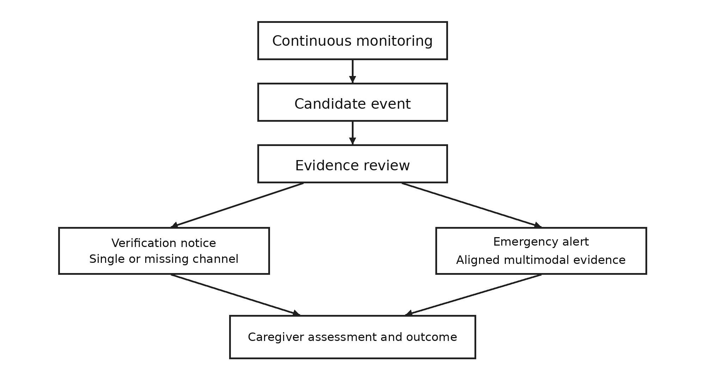
Figure 6-1. Suspected Fall Response and Escalation Workflow

6.4 Exercise Session and Caregiver Review
The older adult initiates an exercise session by selecting an activity. The system announces the activity, extracts body keypoints, identifies the phases of each movement, and increments the count only after a complete repetition. The MVP supports sit-to-stand exercises: a repetition is counted when the seated, rising, and standing phases have been observed in sequence. Counting pauses when keypoints are insufficient or the person leaves the camera view. At the end of the session, the system records valid repetitions, duration, completion against the selected target, and any periods in which counting was unavailable. The caregiver can review the daily record and recent activity trend. Additional activities and technique feedback are reserved for later validation.
6.5 Representative Exception Scenarios
Table 6-2 Representative Exception Scenarios and Expected Responses
Scenario | Expected response
The smartphone is dropped while the person remains standing. | Motion evidence is present, but visual evidence does not support a fall; no emergency event is issued.
The person falls while the smartphone remains on a table. | A visual-only event is marked for verification, with the missing smartphone evidence disclosed.
A fall occurs at the edge of the camera view or in poor lighting. | Visual confidence is reduced; the interface reports degraded coverage and retains any available motion evidence.
The person performs sit-to-stand repetitions. | Complete exercise cycles are counted; repeated recovery to standing is treated as exercise rather than a fall.
Network connectivity or push delivery fails. | Local prompts and event records continue; notification delivery is retried and its delay is recorded.
- 7. Minimum Viable Product and Extensions
7.1 MVP Scope
The MVP covers one older adult, one configured indoor area, one smartphone, one fixed camera, and a defined group of caregiver contacts. It must demonstrate the complete path from sensing and classification to event grading, notification, caregiver action, and outcome recording. It also includes one usable exercise activity. Synchronised recordings may be used for reproducible scenario replay, while at least one end-to-end demonstration should use live device input. Offline model results, replay results, and live system results will be reported separately.
Table 7-1 MVP Functional Scope and Deliverables
Module | MVP capability | Deliverable
Device configuration | Connect the smartphone and camera, align timestamps, record device health, and configure contacts. | Device status and coverage display; notification test record.
Fall recognition | Extract impact and post-impact motion features, estimate visual posture, and combine synchronised evidence. | Normal, verification-required, or emergency decision with an evidence summary.
Event management | Create events, issue local prompts and caregiver notifications, support escalation and closure, and maintain an event log. | Traceable event timeline and outcome record.
Exercise support | Recognise and count sit-to-stand repetitions; record duration and session completion. | Live count for the older adult and a session record for the caregiver.
Operational status | Detect and display occlusion, missing data, disconnection, and reduced monitoring coverage. | Degradation notices and diagnostic records.
7.2 Planned Extensions
Table 7-2 Planned Extensions and Implementation Prerequisites
Extension | Proposed capability | Prerequisite
Additional exercise support | More activities, daily plans, progress summaries, and collaboration among caregivers. | Sufficient annotated movements and evaluation across participants.
Voice confirmation | Speaker verification, response interpretation, and optional language or dialect support. | Testing of erroneous alarm cancellation under realistic household audio.
Wider deployment | Multiple monitored rooms, model optimisation for local devices, and extended home trials. | Compatibility, connectivity, energy, and privacy assessment.
Exploratory analysis | Sound-event summaries, movement quality measures, and balance-related trends. | Explicit definitions, suitable data, and independent validation before user-facing claims.
Outdoor tracking, automatic calls to public emergency services, medical diagnosis, and continuous transfer of raw audio or video are outside the MVP scope.
- 8. System Architecture
8.1 Logical Architecture and Data Flow
The system comprises acquisition and quality control, single-channel perception, multimodal decision-making, user interaction, and event storage. The smartphone records three-axis acceleration with timestamps. A fixed camera supplies video to a local processing device, which extracts body keypoints and posture features. An optional microphone supports local voice interaction when enabled with consent. Acquisition aligns the streams and detects missing or unreliable data. Perception modules produce motion and posture evidence. The decision module creates and updates a graded event. Interaction services provide prompts and notifications, while the storage module retains necessary event metadata, caregiver outcomes, and exercise statistics.
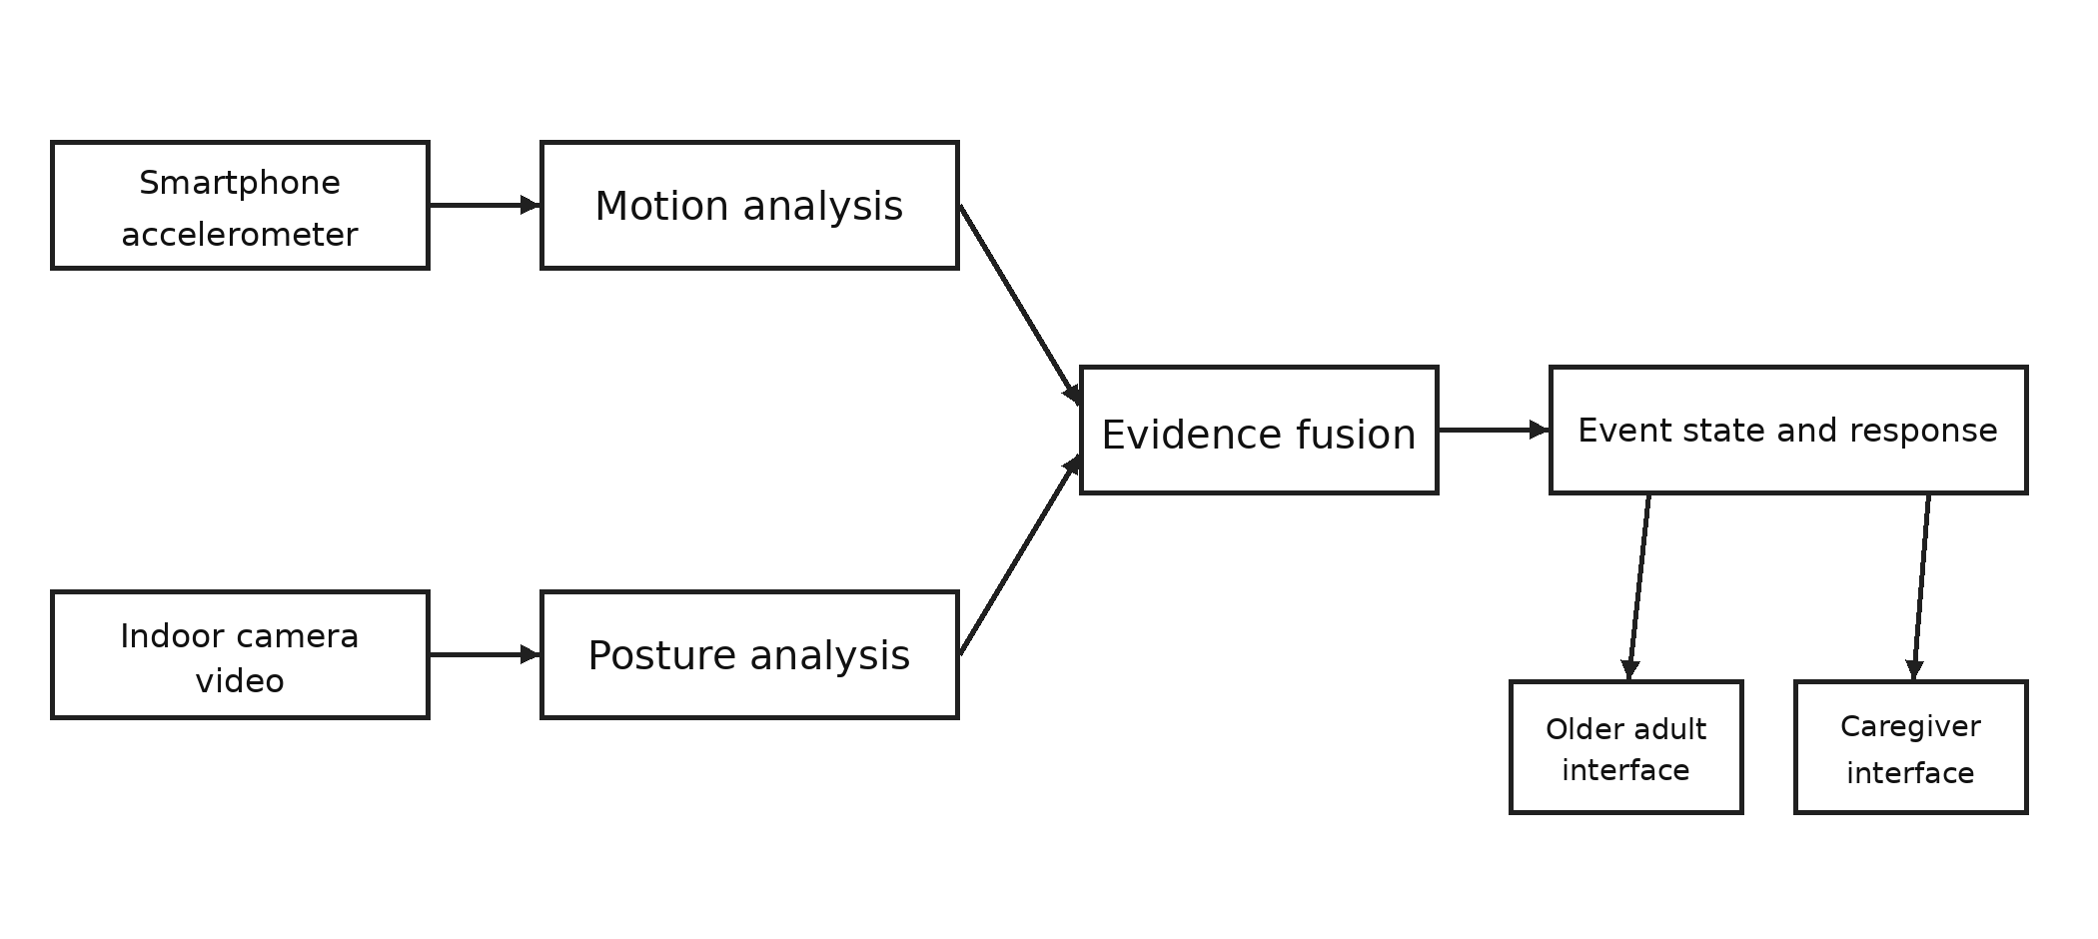
Figure 8-1 System Architecture and Data Flow
8.2 Module Responsibilities
Table 8-1 Core System Modules and Responsibilities
Module | Principal processing | Output
Acquisition and quality control | Align timestamps and assess connectivity, frame loss, occlusion, and sensor availability. | Aligned observations and channel quality flags.
Motion perception | Filter and standardise accelerometer readings; identify impact and subsequent movement. | Motion evidence with an associated confidence measure.
Visual perception | Extract body keypoints and analyse body height, trunk orientation, posture change, and persistence. | Visual fall evidence and exercise keypoint sequences.
Fusion and event management | Combine available evidence with temporal consistency, signal quality, and user feedback. | Event state, escalation decision, and state transitions.
Interaction and notification | Apply contact rules and record notification delivery, viewing, and action. | Older adult prompts, caregiver alerts, and event details.
Storage and reporting | Retain event timelines, outcomes, device status, and exercise statistics. | Audit records and user-facing summaries.
8.3 Deployment, Privacy, and Failure Handling
Raw video and audio are processed within the home wherever the deployment permits; remote services receive event summaries, device status, and exercise statistics rather than continuous recordings. The camera need not run the model itself: a local computer or processing node may perform keypoint extraction. The implementation will define whether short-lived local buffers are necessary, their retention period, access permissions, and secure communication between devices and caregiver applications.
Visual processing cannot depend exclusively on smartphone activity, since the phone may be stationary while a fall occurs in view of the camera. Configurable low-frequency checks therefore maintain visual coverage, with increased processing during candidate events and exercise sessions. Smartphone carriage is treated as an uncertain estimate rather than inferred from an acceleration magnitude near 1 g alone. A failed channel produces a visible degradation state and diagnostic record; missing observations are never interpreted as evidence that no fall occurred.
- 9. Inputs, Outputs, and Result Presentation
9.1 System Inputs
Table 9-1 System Inputs and Intended Uses
Input | Required information | Purpose
Smartphone motion | Device identifier, three-axis acceleration, sampling rate, timestamps, and data-quality indicators. | Detect impact and subsequent activity; estimate channel availability.
Indoor camera | Device identifier, monitored area, frame timestamps, frame rate, and person visibility. | Estimate posture, movement sequence, and exercise repetitions.
Optional voice interaction | Enablement status, prompt delivery, response event, and recognition confidence. | Support post-event inquiry; the MVP does not depend on automatic speaker-based cancellation.
Configuration and feedback | Contacts, escalation order, exercise targets, and caregiver outcome labels. | Govern the response workflow and support evaluation.
Multimodal evaluation requires genuinely synchronised recordings of the same event. Video and accelerometer samples from unrelated participants or sessions may support single-channel training or stress testing, but they cannot be presented as paired evidence for measuring fusion performance.
9.2 Fall Event Output and Report
The caregiver event card identifies the event time, monitored area, priority, and required action. Its detail view explains the observed evidence and the response timeline in plain language. A representative notification reads: “Suspected fall in the living room at 14:32. The smartphone detected an impact followed by reduced movement; the camera detected a rapid decrease in body height and a persistent low posture. A voice prompt was issued at 14:32:08, and no clear response was received by 14:32:18. Please contact the older adult.” The caregiver can initiate contact, confirm safety, or escalate to the next designated contact.
Table 9-2 Monitoring States and Caregiver Actions
State | Presentation | Caregiver action
Monitoring active | Display the monitored area and the time of the latest valid observation. | No action required.
Coverage reduced | Identify the unavailable channel, affected area, and onset time. | Check the device or contact the older adult.
Verification required | Present the available evidence and the missing or inconclusive channel. | Verify the person's condition and record the outcome.
Emergency | Show a high-priority alert, evidence summary, inquiry status, and escalation timeline. | Contact the person promptly and document the response.
A per-event fall report includes an event identifier; occurrence and detection times; monitored area; channel availability and quality; motion and visual evidence; decision level; prompt, delivery, and caregiver-action timestamps; the final outcome; and response duration. An event timeline and concise textual summary communicate the result without attaching raw video or audio by default. Daily or weekly safety summaries aggregate confirmed falls, false alarms, events requiring verification, unresolved events, and periods of unavailable monitoring. Unavailable monitoring is reported separately from periods without detected incidents.
9.3 Exercise Output and Report
The older adult's exercise view displays the activity name, a large live repetition count, target progress, and start, pause, and end controls. When the person is outside the camera view or keypoints are insufficient, the interface indicates that counting is temporarily unavailable. At completion, it presents valid repetitions, duration, and progress toward the selected target. The caregiver view presents a daily session card and recent trends.
A session report records the activity, date, start and end times, valid repetitions, target repetitions, optional set information, interruptions in counting, and a data-quality note. A weekly exercise summary presents participation days, repetitions by activity, and changes over time. Posture scores, balance scores, or claims of reduced fall risk will be included only after their definitions and validity have been established; any such values will be presented as activity indicators rather than clinical assessments.
9.4 Interface Responsibilities
The older adult interface prioritises accessible status information, assistance, exercise counting, and confirmation that a caregiver has been notified. The caregiver interface prioritises current coverage, unresolved events, an explanation of each decision, contact actions, outcome recording, and activity summaries. Skeleton overlays may be used in a technical demonstration, whereas routine caregiver notifications and reports present processed event and posture information.
- Evaluation Plan
- 10.1 Model-Level Evaluation
(1) Fall Detection Model
The fall detection model uses Precision, Recall, and F1-score as the primary evaluation metrics. A confusion matrix is used to analyze the classification performance across the three states: Normal, Pending Verification, and Emergency. In addition, the event-level false negative rate and false positive rate are reported to evaluate the reliability of the system in detecting actual fall events.
(2) Exercise Statistics Model
The exercise statistics model primarily uses MAE (Mean Absolute Error), MAPE (Mean Absolute Percentage Error), and counting accuracy to evaluate the accuracy of exercise repetition counting. For exercises involving multiple movement phases, Precision, Recall, and F1-score are used to evaluate phase recognition performance, while the complete movement cycle detection rate is reported to assess the accuracy of full-cycle detection.

(3) Voice Interaction and Audio Monitoring Model
The VAD module uses Precision, Recall, and F1-score to evaluate voice activity detection performance. Speech response classification is evaluated using Precision, Recall, F1-score, and a confusion matrix for each class. For environmental sound classification, Macro-F1 is used as the primary metric, together with class-wise Precision and Recall. The speaker verification module is evaluated using EER (Equal Error Rate) and TAR@FAR=0.1% to assess identity verification performance.
10.2 Task-Level Evaluation
Task-level evaluation will use synchronised accelerometer and video recordings of simulated falls and challenging non-fall activities. Data will be split by participant or recording before window extraction, with thresholds selected on the validation set. The primary targets are event-level fall recall ≥ 0.95, emergency-alert precision ≥ 0.90, and no more than one false emergency alert per valid monitoring day. Sit-to-stand counting will target a relative error ≤ 5% against manual annotations. Results will be compared with single-sensor and basic fusion baselines and reported by sensor availability and recording conditions. These targets are prospective; results will include sample sizes and representative failure cases.
10.3 System-Level Evaluation
System-level evaluation will assess the complete pipeline through scenario replay and live smartphone–camera testing, with results reported separately. Timestamped logs will measure the time from fall onset to caregiver notification, targeting ≤ 30 seconds, as well as notification delivery and response completion. The system will also be assessed for incremental battery use (accelerometer-only target ≤ 5% per day), seven-day continuous operation, and recovery from camera loss, network interruption, and application restart. Acceptance scenarios will cover normal activities, confirmed falls, single-sensor failures, and unavailable exercise observations.

